**Experiment-3**

**Title:** Integration of Jenkins with Maven and GitHub

**Aim:** Create a job in Jenkins to pull Maven project from GitHub and run Maven goals on it. Display console output as output.

**Pre-Requisite:**

* Java JDK 1.8 or above installed on local machine
* Apache Maven 3.3.9 or above installed and configured on local machine
* Apache Maven project hosted on GitHub

Here we use, <https://www.github.com/NishkarshRaj/Maven-Using-CMD>

* Maven, Git and GitHub plugins in Jenkins.
* GitBash installed in local machine.

**Creating Job for running Maven Commands on Maven Project hosted on GitHub**

1. Click on **New Item** on left side of Jenkins Dashboard.

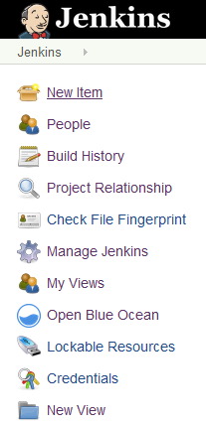

1. Type the **project** name and select **Freestyle** project.

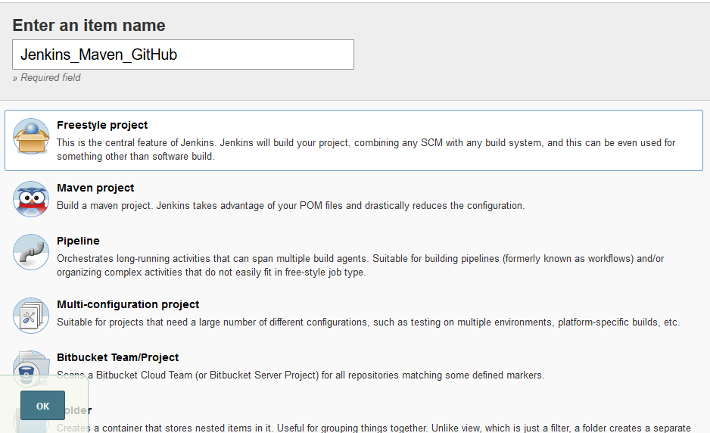

1. Provide **Description** of the project.

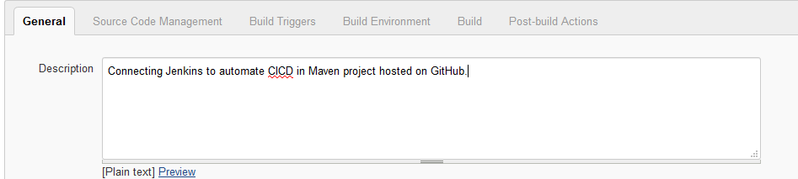

1. In **Source Code Management** Tab, click on Git and specify the URL of the GitHub repository where Maven project is hosted.

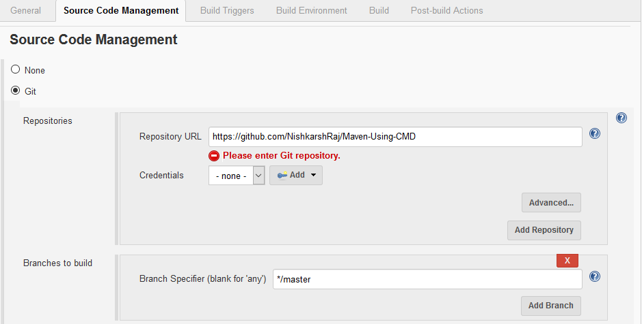

1. In **Build Triggers** tab, check **Trigger builds remotely via scripts** and specify URL of POM.xml file as the **Activation Token**.

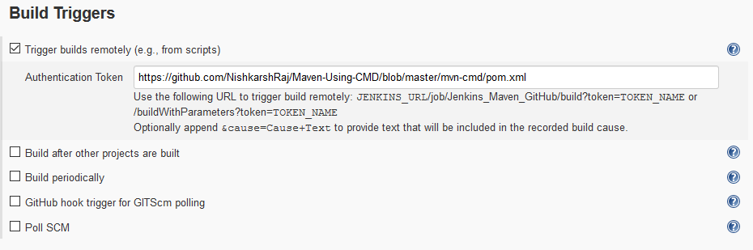

1. **In Build Command** tab, add **Execute Windows Batch command**, and type:

* Mvn clean
* Mvn compile
* Mvn install

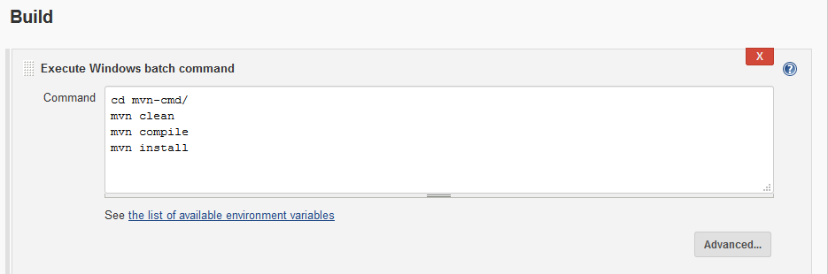

1. Click on OK. The job is created.
2. Build the job.

**Output:**

